 

Dr. André Revil 10/10/2024

EDYTEM

Université de Savoie Mont-Blanc,

Campus Universitaire Savoie Technolac,

73376 cedex, Le Bourget du Lac, France. To: The Editor of Geophysics

[andre.revil@univ-smb.fr](mailto:andre.revil@univ-smb.fr)

T. 33+(0)479 758 715

Dear Editor,

Please find enclosed a manuscript entitled “3D joint inversion of induced polarization and self-potential data for ore localization” by Zhaoyang Su, Jinsong Shen, André Revil, Zhongmin Zhu, and Ahmad Ghorbani, for submission to Geophysics. Thank you for encouraging us to resubmit our manuscript. We also thank the Associate Editor and the four referees for their time and very useful comments. Please find below a keyed response to their comments. A copy of the manuscript with the tracked changes overlaid in yellow is also provided. We hope that you will be satisfied by this revision.

Best regards

Dr. André Revil on the behalf of the authors.

**Assistant Editor 1**

The AE wrote *“it seems that there is some overlap to an already published paper. Before you resubmit your work provide us with a clear statement what is new in your submitted work. Please follow in detail the instructions of the AE.”* Response: Thanks, we have made a clear statement about the innovation of this paper. And we will upload the statement when we resubmit. Thanks.

**Associate Editor 2**

1. The AE wrote “*This manuscript presents a joint inversion approach applied to IP and SP, aimed at mineral exploration. The method was tested on synthetic models and a sandbox experiment. The manuscript is well organized, and it is interesting to see the widely accepted cross-gradient method being applied to IP and SP. However, it received polarized feedback from reviewers. I agree with some of the issues, particularly those related to the overlap with a previous paper by Su et al. (2024), as pointed out by two reviewers. For example, "Some pictures of the manuscript look like identical to some from Su et al. (2024), for example figure 9e (manuscript) and Figure 10 from Su et al. (2024)". Compared to Su et al. (2024), this manuscript provides an incremental update by introducing cross-gradient-based joint inversion and K-Medoids, which could be valid for a new publication. However, considering the concerns raised by reviewers, I would suggest that the authors resubmit this work after addressing the comments and suggestions provided.”*

Response: Thanks for your positive comment on the joint inversion of IP and SP data. We indeed utilize the same dataset from the sandbox experiment by Su et al (2024), but we have gone beyond previous work by jointly inverting the IP and SP data using cross-gradient constraint, incorporating the ORI index and K-Medoids clustering algorithm. This approach finally successfully identified ore bodies associated with strong chargeability (IP) and/or source current density (SP). IP and SP methods are wildly used in the exploration, hydrogeology and other fields. Mostly previous works are joint interpretation of these two datasets. To our knowledge, joint inversion of IP and SP data has not been published in journals or conferences. We believe that our paper will appeal to the interest of widest possible international Geophysics and Geophysics audiences. Furthermore, we have revised the figure in the revised manuscript and provide a keyed response to all the referee’s comments, we hope that you will satisfied this version. Thank you very much.

2. The AE wrote “*Page 9, Line 173: change "predicted" to "measured" or "observed".”* Response: We agree with the comment. Change done. Thank you.

3. The AE wrote “*Page 13, Line 252: why RMS = 1 at the first iteration? additional normalization?*” Response: As we descript in the paper, the RMS is defined as

 (1)

At the initial iteration, the predicted data , and the ,so the RMS=1. Then RMS will reduce after several iteration.

4. The AE wrote “*Page 19, Line 372: change "14cm" to "14 cm".*”Response: We agree. Change done, Thanks.

5. The AE wrote “*Figure 3: label "F)" is covered.*” Response: We agree. Change done, thanks.

6. The AE wrote *“Figure 8: comparing "d)" and "c)", seems* *K-Medoids didn't perform very well?”* Response: An important issue is how to determine the number of cluster center. Sun and Li (2015) discuss the effects of using an inaccurate number of clusters in joint inversion. If the designed number of cluster center exceeds the real number of geologic units, artifact will surround the major anomalous bodies. One of the reasons for this is the smooth constrain in the geophysical inversion. The same situation is in Figure 8h in the revised manuscript. Figure 9c classifies four clusters using the K-Medois clustering algorithm, and the determined cluster centers is 0.003, 0.246, 0.790 and 1.466 (Figure 9d). The cluster center at 0.246 (<0.5) denotes the artifact where surrounding the real anomaly bodies. However, we can see in figure 8 that the K-Medoids clustering improve the revolution. Additionally, there are several methods available to determine the optimal number of clusters (Paascheetal et al (2010); Xie and Beni, 1991). We discuss this in the revised manuscript (line 351 - 356).

**Reviewer 1**

1. The Reviewer wrote *“As you quite correctly say in lines 36 to 41, SP signals can come from a number of different sub-surface scenarios other than mineralization or ore bodies. So, there are a lot of situations in which an IP response and an SP response in the same general area could be coming from two completely independent, unconnected features/phenomena in the subsurface. This is actually rather nicely illustrated by your real-data laboratory example (which I like) which contains two features, one of which is giving an IP response and the other of which is giving an SP response. This is a perfect example of where one does an IP survey, models and interprets the data from that survey, and finds the IP target (i.e., zone of non-zero chargeability in the ground), then one does an SP survey, models and interprets the data from that survey, and finds the SP target (i.e., the charge concentration that's acting as a source of the SP potential field): In other words, two entirely independent surveys finding two entirely independent targets/phenomena in the ground. I think you need to discuss the issue of when one can expect to have an IP response and an SP response from the same target (maybe different parts of the same target). What is required of an ore-body in order for it to give an IP response and an SP response? How often does this occur? provide some real examples of these kinds of ore-bodies or mineralization. You need to justify why *joint* inversion is a worthwhile thing to do. At the moment, the lab example actually nicely illustrates that joint inversion is not required, and* *that the combination of an independent IP survey and an independent SP survey are exactly what's required to identify and locate the two different targets.”*

Response: Thank you for your meaningful comment. Some metal deposits on land exhibit both polarization effect and SP anomaly, simultaneously (Figure 1 in cover letter). We have added some case study in the introduction (line 36-44 in the revised manuscript). This is similar to the case study 1 in our manuscript. Joint inversion truly enhances the resolution and got a consistent structure (figure 5 in the revised manuscript). In case study 2 and the sandbox experiment, we designed two anomalies with different sizes, and aims to evaluate the effectiveness of joint inversion with cross-gradient constraint when the petrophysical boundaries of anomaly are different. We could perform independent IP and SP survey to identify the two different targets, separately. But we think that the result from joint inversion is better (compare figure 7 to figure 8). Both IP and SP data are associated with the charge distributions beneath the subsurface or subseafloor (Everett M., 2013) IP is sensitivity to ore deposits containing disseminated metallic particles (e.g. pyrite, magnetite). The occurrence of SP anomaly requires three conditions, including the presence of electron donors and electron acceptors, as well as an electronic conductor facilitating electron transport over long distances (Revil and Jardani, 2013). In sandbox experiment, anomaly S2 is above on the water table (Figure 2 in cover letter), so, no SP signal is generated and can’t be identified from SP inversion (figure 11 e and f).There are several reasons to joint inversion of IP and SP data: (1) The inverted chargeabilityfrom the IP inversion and source current densityfrom SP inversion both reflect the structure of ore bodies (2) Conductivity distribution as a prior information in the IP and SP inversion. (3) Joint inversion with cross-gradient constraint reduced the model ambiguity. So, we think the joint inversion of IP and SP data yields a superior reconstruction of ore bodies. We update the introduction in the manuscript.

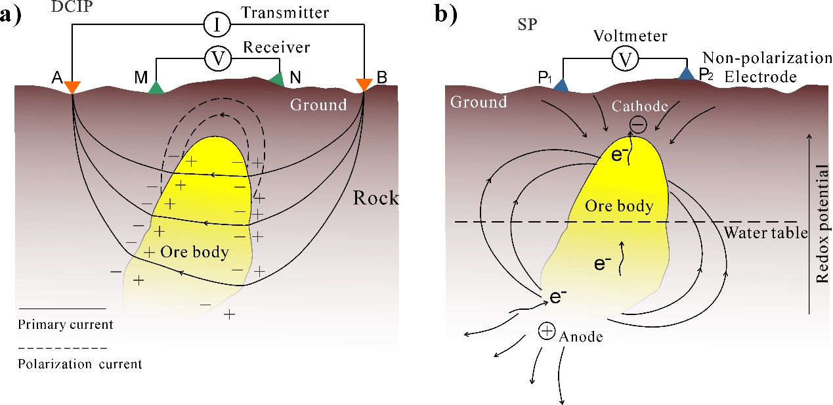

**Figure 1.** The diagram of DC-IP and SP method. (a) DC-IP experiment showing primary current path and polarization current build up around the conductivity ore body. (b) Sketch of the geo-battery model associated with a conductivity ore body below ground surface (figure 1b modified from Revil and Jardani, 2013).

.



Figure 2 Experiment setup. (a) A plastic tank is filled with water-saturated sand, where two metallic bodies are buried. ABEM Terrameter SAS-4000 is used to perform both the ER and IP data measurements. (b) The positions of buried anomalies in () up view. (c) The height of water table during the experiment. (d) The height of buried metal bar from the front () view.

2. The Reviewer wrote “*You may want to consider Lelièvre et al. (2012; https://doi.org/10.1190/geo2011-0154.1) as an example for petrophysical joint inversion. This paper precedes the work of Jiajia Sun & Yaoguo Li. Also, petrophysical approaches don't need to be just cooperative, as line 44 suggests.*” Response: Thank for your recommendation, A nice paper illustrate several strategies of joint inversion. We cited this in the manuscript (line 56, line 65-67).

3. The Reviewer wrote “*Line 69-73: Explicit calculation and storage of the Jacobian matrix is not necessary. There are "implicit" ways of doing the calculations that involve the Jacobian matrix, e.g., Rodi & Mackie (2001;* [*https://doi.org/10.1190/1.1444893*](https://doi.org/10.1190/1.1444893)*), Jahandari & Farquharson (2017;* [*https://doi.org/10.1093/gji/ggx358*](https://doi.org/10.1093/gji/ggx358)*). These approaches require much less memory, and can be faster.*” Response: We agree with you. We can compute the Jacobian (sensitivity) matrixor its transposetimes a vector  at Gauss–Newton step as it amounts to solving one forward problem or one adjoint problem. Actually, we use this method in independent inversion. But, I think the matrix

 (1)

should be calculated in the full joint inversion. The objective function of full joint inversion can be solved by the following the equation system,

 (2)

where the matrix

, (3a)

, (3b)

, (3c)

, (3d)

, (3e)

, (3f)

. (3g)

4. The Reviewer wrote “*Do you actually use the methodology given in equations 11 to 19? From my understanding at the moment I don't think you do. You present these, then give some of the disadvantages of the approach, then proceed to give the equations (and description) for the approach you do use, namely, lines 213-231 and equations 20-22? If this is the case, you don't need to give nearly as much detail about the method you do not use: that's just wasting space in the paper (and maybe increasing the page charges for this paper?).*” Response: Thank you for your suggestion, and we have deleted this part in the revised manuscript.

5. The Reviewer wrote “*Why do you think the S1 metallic "body" (what is it? a metal can? a solid metal cylinder (probably not as it's not showing up as a conductivity high?)) is giving an IP response? Should it be giving an IP response?*” Response: The anomaly S1 is a metal can with liquid (figure 10b), and it indeed exhibits a strong IP phenomenon. We measured one point above the S1 using a Wenner array before the IP measurement.

6. The Reviewer wrote “*For the SP inversion, is it actually current density you're inverting for, or is it charge density? (My expectation would've been charge density, but your plots are labelled current density.)*” Response: Usually, volumetric source current density distribution  (A/m3) or source current  (A/m2) is inverted in the SP inversion, and we choose  in this paper.

**Reviewer 2**

1. The Reviewer wrote “*Compared to independent inversion, multi physics field joint constraint inversion can more accurately obtain geological anomaly information. The joint inversion of IP and SP proposed in the article effectively improves the inversion accuracy of the model set in this article”.* Response: Thanks, indeed, the inverted chargeability model and current density model by joint inversion closely resemble the true model, and improve the inversion accuracy.

2. The Reviewer wrote “*The natural potential method belongs to the passive source method. As is well known, the detection of the passive source method has certain conditions. Do the two abnormal bodies arranged in the sandbox described in the article have conditions for generating natural potential? Moreover, it is difficult for physical models constructed in a short period of time to generate SP for detection. Whether the SP observed in the experimental data in this article is the true natural potential needs to be verified.”* Response: We agree that the occurrence of source current density beneath the surface requires conditions: the presence of electron donors and electron acceptors, as well as an electronic conductor facilitating electron transport over long distances (figure3, also see Revil and Jardani, 2013). In our sandbox experiment, the anomaly S2 is a metal bar. To accelerate the corrosion, the outer protective oxidation layer was removed. A mixed acid solution with a conductivity of 0.031 S/m at a temperature of 24.9°C was poured into the bottom of the sandbox through a vertical plastic tube. The water table was maintained approximately in the middle of the anomaly S2. Oxidation of the metallic body at depth and reduction of oxygen near the surface, the anomaly S2 (metal bar) serves as an electronic conductor to transfer electrons (figure 1a). The anomaly S1 is above the water table and ano redox reaction occurs (anomaly S1). So, the negative SP signal is only attributed to a redox reaction occurring around anomaly S2 (similar previous study in Rittgers et al., 2013), By the way, there is no another potential, such as streaming potential.

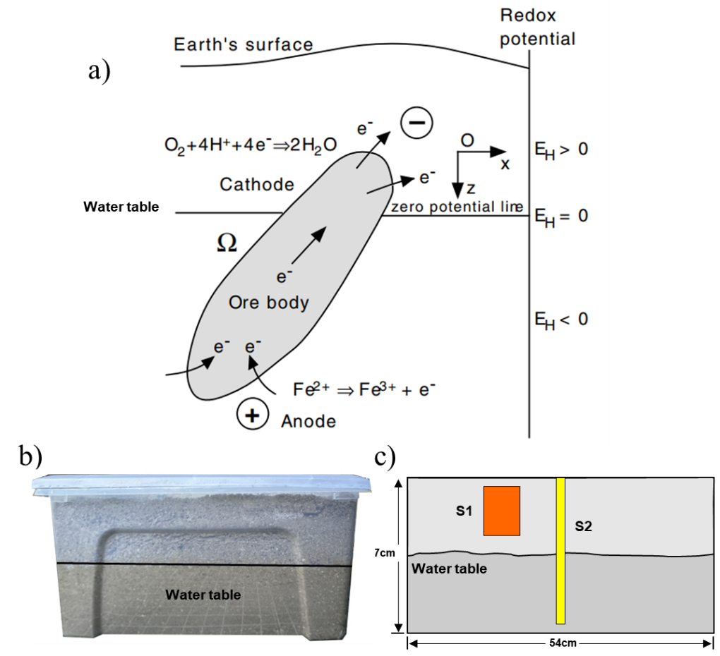

**Figure 3.** Sketch of the classical geobattery model proposed for ore bodies (figure 1a from Revil and Jardani, 2013).

3. The Reviewer wrote “*Geophysical exploration targets the earth, so whether it is forward modeling or inversion, special treatments will be applied to several boundaries except for the ground-air boundary. For the sake of aesthetics, common geophysical inversion programs or software usually do not display results outside the observation system range, but cannot be ignored. The experiment in this article was conducted using a plastic box, and the electrodes were placed very close to the boundary of the plastic box. Therefore, the inversion process cannot ignore the processing of the boundary, and the processing flow is not described in detail in the article”.* Response: Yes, in a field experiment, the potential approaches to zero at infinite. But in sandbox experiment, boundary condition is Newman condition (current density perpendicular to surface is zero). And we descript the description in the revised manuscript (line 402-405). Thanks.

4. The Reviewer wrote *“the references cited in the article, “Combining Electrical Resistivity, Induced Polarization, and Self-Potential for a Better Detection of Ore Bodies (SU, 2024)”, have many similarities with the content of this article. Please carefully review”.* Response: Thank you for your reminder. We use the data from Su et al., 2024. But the idea is totally different, this paper we focus on the joint inversion of IP and SP data. We have updated the manuscript.

5. The Reviewer wrote *“The low-frequency geoelectrical methods described in lines 22-23 of the introduction, including ER and SP methods, are unreasonable. They all observe steady-state electric fields without frequency changes. In addition, the time-domain IP method referred to in this article does not belong to the frequency domain range”* Response: Here, low frequency method denotes the frequency below 10 kHz. True, SP is passive method and ER use a direct current inject to the ground and obtained DC resistivity. The IP method is a natural extension of the ER method, and we think all of them belong to the low-frequency method.

6. The Reviewer wrote *“The introduction needs further revision”* Response: We have updated the introduction in the revised manuscript, and we hope you will satisfy this version.

7. The Reviewer wrote “*In "Methodology", the objective function formulas (3) and (10) have the same overall form except for different parameter superscripts. It is recommended to summarize them*”. Response: We have updated these equations and add subscripts to distinguish them. Thanks.

8. The Reviewer wrote *“Are dpred and dobs of lines 171-172 both predicted data?”* Response: Thanks for the comment. These typos have been corrected. Thank you.

9. The Reviewer wrote *“What is the reference model mref in the article? Is it the initial constraint model or the new model obtained from each iteration update? Please explain”* Response: The reference model in this paper is initial homogeneous model, we have explained in the revised paper (line 303).

10. The Reviewer wrote *“Please confirm if the expression of formula (23) RMS is correct. The root mean square error should be the root mean square error between simulated and observed data,* *independent of observation noise”.* Response: We confirm the definition of RMS is correct in this paper. The value of RMS is depended on how the authors define the RMS. Normally we use the following equation

 (4)

and the data misfit term is

 (5)

Here, the value of RMS is depended on the data weighting matrix. When the is an Identity matrix, RMS is independent of observation noise. However, we can use the different data weighting matrix, especially in TEM inversion. In this paper, to evaluate the different data misfit of the joint inversion, the RMS is defined as

 (6)

At the initial iteration, the predicted data , and the ,so the RMS=1. Then RMS will reduce after several iteration. This eliminate the influence of data weighting matrixin different method.

11. The Reviewer wrote *“The numerical simulation cases do not provide a detailed observation system, such as the distance between observation points, device form, etc;”* Response: We mentioned that IP and SP data are collected by using the same protocol as the sandbox experiment in section numerical case study (line 304-305), and more detail in the section data acquisition.

12. The Reviewer wrote *“Please provide an overview of the physical experiment section of this article, whether it meets the similarity criteria for physical simulations;”* Response: Anomaly S1 has the IP phenomenon and no SP anomaly (buried above the water table), and Anomaly S2 (small size) has the IP phenomenon and SP anomaly. Two anomalies represent the typical metal deposits, and the purpose of this experiment is to verify the advantage of joint inversion of IP and SP inversion with cross-gradient constraint. At the same, our sandbox experiment demonstrates the condition of redox reaction occur. We think our experiment is meaningful.

13. The Reviewer wrote *“On line 315, the current density unit A m-3 should be consistent with the current density at other positions.”* Response: We have modified, thanks.

14. The Reviewer wrote *“How does the joint inversion method mentioned in the article overcome the convergence and parameter determination problems in the traditional inversion process when dealing with IP and SP data?”* Response: The convergence and weighting parameter determination is relatively different in the full joint inversion. Therefore, the objective function comprises three components: two independent parts and a cross-gradient joint function. The important point is solving the following equation,

. (7)

The parameters  and  are used to balance the weights of the model perturbation, which is depended on the amplitude of  and , and parameter  is used to control the cross-gradient constraint. We reduce the number of parameter and make it easier to convergence.

15. The Reviewer wrote *“The design of sandbox. Can you explain the reason for this design, does it have actual example in geological field?”* Response: (1) This sandbox experiment demonstrate that the occurrence of SP anomaly needs three condition, and that is why we only observed SP anomaly above S1. (2) In laboratory studies, it has been found that the chargeability  is controlled by the volume fraction of metallic particles except the grains are below a percolation threshold (< 22 vol.%) (Revil et al., 2015). Given the small diameter of the S2 (compare to electrode distance), so it isn’t easy to polarization. However, combining the SP data, we successfully identified S2. (3) The anomaly S1 exhibits only the IP phenomenon but no SP anomaly, which verifies the effectiveness of the cross-gradient constraint that it does not force the two models into conformity. For some metal deposits on land or seafloor, they do exhibit polarization effects and simultaneously generate SP anomalies. Sultan et al. (2009) reported a multi-geophysical survey at Wadi EI Beida to delineate the mineral ore deposits, including the magnetic, IP and SP survey. Horo et al. (2020) combined SP, ERT and IP data together estimated depths of gold prospective zones. Nakayama and Saito (2018) developed Time Domain Ocean Bottom EM System and measured magnetic, IP and SP anomalies at hydrothermal deposits below the seafloor. we believe our experiment is meaningful.

16. The Reviewer wrote *“The field situation is extremely complex, including the surface complex, underground complex and so on, in this case, what method can do the best depth conversion? Those minerals are suitable for this algorithm?”* Response: When we program the code, we have considered the topography and depth weighting approach in the SP inversion. We also agree with you that the field work is more complex than sandbox experiment, especially noise in the data. We think our code can process the field data.

17. The Reviewer wrote *“If the actual situation, the metal ore body is not easy to be activated, how to deal with it?* Response: In laboratory studies, it has been found that the chargeability is controlled by the volume fraction of metallic particles, such as pyrite and magnetite except the grains are below a percolation threshold (< 22 vol.%) (Revil et al., 2015). If a metal ore body isn’t easy to polarization under the primary current, it may have no economic value in the current condition.

18. The Reviewer wrote *“How do the authors deal with the multi-physical property changes of geological bodies through the joint inversion method, and how do these changes affect the inversion results?”* Response: The cross-gradient constraint terms  requires the spatial changes occurring in the same or opposite direction during the inversion (i.e. the inverted final models have the same structure). But it does not force the two models into conformity when some part of the models is homogeneous (i.e. ), and significant change only in another models (). We can adjust the parameter to control the cross-gradient constraint. control the cross-gradient constraint. Ifis too small, the cross gradient doesn’t work. On the contrary, model perturbation changing too much will influence the convergence at the next iteration.

19. The Reviewer wrote *“Does the author think that the limitation of proposed method? The challenges that may be encountered in actual geological exploration.”* Response: Joint inversion is a non-linear problem, and current gradient-base solvers are easy to converging to local minima. The volumes of measured geophysical data for 3D investigation are expected to rise during the field work. We should overcome the computational challenges. Moreover, the presence of noise in the data (sometime low S/N ratio), making the convergence more difficult to achieve. We will focus these problems in the next step.

**Reviewer 3**

1. The reviewer wrote *“The sequential inversion approach employed in this study has been previously detailed in several publications, albeit for different datasets. Notable examples include: Gao, J., & Zhang, H. (2018). An efficient sequential strategy for realizing cross-gradient joint inversion: Method and its application to two-dimensional cross borehole seismic travel time and DC resistivity tomography. Geophysical Journal International, 213(2), 1044–1055. Tavakoli, M., Kalateh, A. N., Rezaie, M., Gross, L., & Fedi, M. (2021). Sequential joint inversion of gravity and magnetic data via the cross-gradient constraint. Geophysical Prospecting, 69(7), 1542–1559. I do not observe any innovation in the inversion methodology itself, aside from the application to a different dataset. It remains uncertain whether this type of sequential inversion has previously been applied to IP and SP data sets. Nevertheless, I find the prior references more compelling and detailed than this manuscript. Additionally, the manuscript is poorly written; the abstract lacks specific achievements (if any) and is filled with general statements, a pattern that continues throughout the text. In its current form, I believe this manuscript does not meet the publication standards for GEOPHYSICS.”*

Response: We appreciate the comments by this Reviewer. The novelty lies more in the joint inversion of SP/IP data in the context of mineral exploration than in the joint inversion of geophysical data generally speaking. That said, in programming the joint inversion code, we try to solve the objective function of full joint inversion (five parts: two data misfit term, two model constraint terms and cross gradient constraint term). Many weighting parameters need to determined, and making the convergence changing. To address this, we adopted the strategy of joint inversion proposed Gao and Zhang (2016), and split the objective function to several part (Um et al. 2014). We cited these reference in the manuscript and we have added the new reference in the revised manuscript. The integration of IP and SP data has proven useful tool in the exploration of ore deposits, characterization and monitoring in hydrogeology, recently successfully used in Groundwater flow paths (Revil et al. 2024). We believe that jointly inverting these two datasets is meaningful. (1) IP and SP data are associated with charge distributions beneath ground surface or seafloor. The inverted chargeability (dimensionless) and volumetric source current density (A/m3) both reflect the structure of ore bodies. (2) Joint inversion with cross gradient constrains reduced the model ambiguity. (3) Conductivity distribution obtained from ERT as a prior information in IP and SP inversion. Moreover, we introduce the ORe body Index (ORI), calculated using normalized inverted model parameters from our joint inversion. We then apply the K-Medoids clustering algorithm to automatically categorize the ORI into different clusters. This approach enables us to successfully identify ore bodies associated with strong chargeability (IP) and/or source current density (SP). To the best of our knowledge, joint inversion of IP and SP data has not been published in journals or conferences. We have updated the manuscript and hope the Reviewer will find our work valuable and suitable for Geophysics.

**Reviewer 4**

1. The Reviewer wrote “*This manuscript presents an approach for jointly inverting IP and SP data by incorporating a cross-gradient physical property function, which is minimized together with the inversion of data. A sound formulation for evaluating gradients during non-linear data inversion is presented. The proposed method is illustrated using synthetic models and a real data set from a tank experiment. Overall, I consider this contribution to be valuable for people involved in mineral exploration of base-metal resources that utilize IP and SP investigations. The manuscript is well-written and organized, and no suggestions are made regarding these aspects.*” Response: Thanks for your positive comments. We believe that the joint inversion of SP and IP data may play an important role in the exploration and evaluation of metal deposits. We hope that you will be pleased with the revised version of the manuscript.

2. The Reviewer wrote “*Common cross-gradients seem to make sense when physical property distributions inferred from each geophysical method share some kind of structural similarity. This is the case for resistivity distributions from ER-EM data inversion or from ER-Seismic joint inversion, as resistivity targets may have higher travel time velocities. Is this also true for IP and SP inversion? The chargeability of IP can be linked to volume-based distribution, but this does not apply to the current distribution of SP, which has interfacial properties. For metallic ore bodies, a current source mechanism is generated through electrochemical reactions taking place at the interfaces of the bodies, as shown (for example) in models developed by Sato and Mooney (1960) 1and experimental contributions from Castermant et al. (2008). For this reason, the manuscript should provide: a) a physical explanation for a bulk SP current (not an interfacial one);b) a discussion about how the assumption of a common cross-gradient constraint may shape or misshape a true distribution when a bulk distribution is valid for one of the distributions but not for the other one.*” Response: IP and SP data are associated with charge distributions beneath ground surface or seafloor (figure 4). The charge distributions are established by the application of external electrical energy in the IP survey. Charge distribution is maintained by naturel electrochemical processes (Everett, 2013), and self-potential anomalies observed in the SP survey. The chargeability (dimensionless) and volumetric source current density (A/m3) inverted from the joint inversion both reflect the structure of ore bodies.  and  both are linked to volume-based distribution. The cross-gradient in this paper can be written as . We have added these descriptions in the introduction section and the methodology section. Thank you again.



**Figure 4.** The diagram of DC-IP and SP method. (a) DC-IP experiment showing primary current path and polarization current build up around the conductivity ore body. (b) Sketch of the geo-battery model associated with a conductivity ore body beneath the ground surface (Figure 1b modified from Revil and Jardani, 2013).

3. The Reviewer wrote “*Does a k-Medoid model actually* *fit the observed dataset? Let me try to explain it. A model p can be accepted as a data inversion solution if allowing data fitting to observed data set d0, such that residuals d0 - F(p) are minimal, with F as the model functional response. A* *cluster analysis, however, operating on model p provides models (or clusters) p1, p2, and so on that are useful to better outlining subsurface targets. However, do p1 or p2 already allow fitting to the observed data? Even for simple linear problems, it is not expected. Therefore, if the observed data set is not honored, should such pictured cluster models be accepted as a physically based model representation? I am not sure. Of course, some kind of model enhancement is necessary to facilitate data interpretation, but some comments discussing whether such models already satisfy the minimal d0-F(p) should be addressed. I apologize if my understanding of cluster analysis was missed at some point (I am not a specialist in the subject)*.

Response: Thanks for your comment that is totally meaningful. Indeed, operating cluster analysis on the inverted final model  to obtain a new model  enhances resolution but we cannot guarantee that the new model fit the observed dataset. It is only used to help us to classify the geologic units. By combining geological knowledge with clustering results, geologists can be more insightful with respect to the the spatial distribution and nature of various geological units. That said, it is better to incorporate statistical petrophysical data into the objective function of joint inversion using the c-means clustering (see Sun and Li, 2015). This will guarantee the inverted model to fit the observed dataset. Another important point is the number of cluster center, Sun and Li (2015) discussed the case for which the prior petrophysical information is incomplete and inaccurate (i.e., the number of cluster center is wrong), and artifacts will be generated if the number of clusters is higher than in reality. But in this paper, we didn’t operate the cluster analysis on the inverted final model . We use the K-Medois clustering algorithm to automatically categorize the ORI. The ORI () is calculated according to the inverted model  using the following equation,

. (8)

According to the value of ORI, we classify the results into three cases: (1)  denotes the background. (2) if the ore bodies only have one of the characters (chargeability or current density), the value is given by ; (3) if the ore bodies both showed high chargeability and source current density anomaly, and the value  range from 1 to 2. As you know, determining an appropriate number of clusters is a difficult task. If the number clusters is smaller than the number of lithofacies, the ore associated anomaly will vanish in the background.

4. The Reviewer wrote “*No information is provided regarding the redox gradient of the tank. This information is necessary because the redox potential is considered the primary potential that* *drives the SP anomaly in the simulated condition.”* Response: This is not the goal of our manuscript to invert or determine the redox potential responsible for the SP anomaly. It is enough to say that the resulting self-potential signal is associated with a causative current source. The source current density below the surface and the redox potential has a relationship (see Linde and Revil, 2007)

, (9)

where  denotes the electrical conductivity. Castermant et al (2008) has performed a controlled sandbox experiment about the corrosion of a metallic body. A dipolar self-potential anomaly is produced with a positive pole at depth, which agrees with the prediction of the geobattery model of Sato and Mooney (1960). We did not measure the redox potential distribution in this experiment. We believe that this experiment satisfied the condition of SP anomaly occurrence: the presence of electron donors and electron acceptors, as well as an electronic conductor (Revil and Jardani, 2013). Neglect the secondary source term associated with the jump in electrical conductivity (second term on the right side of the equation 10)n the SP anomaly generated by subsurface natural current sources are associated with redox-active environments where metal bar is located (first term on the right side of the equation 10).

. (10)

5. The Reviewer wrote *“Inform the composition of the targets (iron, graphite…).”* Response: Stainless steel. We have added this information in the revised version of the manuscript (lines 370-378), Thanks.

6. The Reviewer wrote *“In the tank experiment, the IP response was observed under a volumetric current (current of 200 mA divided by a volume of 0.065 m3) of 3.08 A/m3. Is this condition scalable to* *field investigations where the current intensity is often limited to a* *few amperes, but the volume under investigation may extend to 103 m3 or more?”* Response: Yes it does. Indeed, in the IP experiment, the maximum injection current is set to 200mA. Given the electrode distance is 6 cm (y-direction) and 4 cm (x-direction), the small diameter of the anomaly S2 (2.5 cm) poses a challenge. To polarize this metal bar S2, we increased the injection current. Even if a volumetric current density of 3.08 A/m3 is not possible in the field, the electrode distance is also different and the actual size of the ore body is expected to be larger. There are enough showcases demonstrated polarization of ore bodies using the IP method using a the primary current of a few amperes.

7. The Reviewer wrote *“It would be important to differentiate between the contributions of the joint approach and those of Su et al. (2024) who conducted research using the same dataset. Some pictures of the manuscript look like identical to some from Su et al. (2024), for example figure 8e (manuscript) and Figure 10 from Su et al. (2024).”* Response: Thank you for your reminder. We use the experiment data from *Su et al. (2024)* but the present paper focus on the joint inversion of IP and SP data, and combining defined ORI and K-Medoids clustering to better delineate the ore bodies. This is definitely a novel work in our opinion. In order to reply to the comment, we modified Figure 10 in the revised version of the manuscript.

8. The Reviewer wrote “ORe or ORI? Do the two terms refer to the same thing?” Response: “**OR**e body **I**ndex” abbreviated as “**ORI**”. This is now better explained in the revised version of the manuscript.

9. The Reviewer wrote *“Line 282orto denote ORI?”* Response: Yes, we unified the expression and the letterdenotes the ORI in the whole revised manuscript. Thanks.

10. The Reviewer wrote “*Are the metallic targets in the tank cubic or* *cylindrical? In Figure 9, one of them is depicted as cylindrical, but in the text, its dimensions are described as cubic-like*” Response: The two targets are cylindrical in the sandbox experiment. We have changed the figure 10-12 in the revised manuscript to avoid any misunderstanding, thank you.

**Cited Reference**

Castermant, J., Mendonça, C. A., Revil, A., Trolard, F., Bourrié, G., & Linde, N. (2008). Redox potential distribution inferred from self‐potential measurements associated with the corrosion of a burden metallic body. *Geophysical Prospecting*, *56*(2), 269-282.

Gao J., and H. Zhang. 2016, Two-dimensional joint inversion of seismic velocity and electrical resistivity using seismic travel times and full channel electrical measurements based on alternating cross-gradient structural constraint: Chinese Journal of Geophysics. **59**(11), 4310-4322, doi: 10.6038/cjg20161131. (in Chinese)

Linde N. and Revil A. 2007. Inverting residual self-potential data for redox potentials of contaminant plumes. Geophysical Research Letters 34, L14302. doi:10.1029/2007GL030084.

Revil, A., Karaoulis, M., Johnson, T., & Kemna, A. (2012). Some low-frequency electrical methods for subsurface characterization and monitoring in hydrogeology. *Hydrogeology Journal*,*20*(4), 617.

Revil, A. and A. Jardani, 2013, The self-potential method: Theory and applications in environmental geosciences: Cambridge University Press.

Rittgers, J. B., Revil, A., Karaoulis, M., Mooney, M. A., Slater, L. D., & Atekwana, E. A. (2013). Self-potential signals generated by the corrosion of buried metallic objects with application to contaminant plumes. *Geophysics*, *78*(5), EN65-EN82.

Revil, A., Abdel Aal, G. Z., Atekwana, E. A., Mao, D., & Florsch, N., 2015, Induced polarization response of porous media with metallic particles—Part 2: Comparison with a broad database of experimental data, Geophysics, 80(5), D539-D552.

Sultan, S. A., Mansour, S. A., Santos, F. M., and Helaly, A. S., 2009. Geophysical exploration for gold and associated minerals, case study: Wadi El Beida area, South Eastern Desert, Egypt. Journal of Geophysics and Engineering, **6**(4), 345-356, doi: 10.1088/1742-2132/6/4/002.

Sun, J., & Li, Y. (2015). Multidomain petrophysically constrained inversion and geology differentiation using guided fuzzy c-means clustering. Geophysics, 80(4), ID1-ID18.

Paasche, H., J. Tronicke, and P. Dietrich, 2010, Automated integration of partially colocated models: Subsurface zonation using a modified fuzzy c -means cluster analysis algorithm: Geophysics, 75, no. 3, P11–P22, doi: 10.1190/1.3374411.

Xie,X. L.,and G.Beni,1991,Avalidity measurefor fuzzyclustering:IEEE Transactions on Pattern Analysis and Machine Intelligence, 13, 841–847, doi: 10.1109/34.85677.

Um, E. S., M. Commer and G. A. Newman, 2014, A strategy for coupled 3D imaging of large-scale seismic and electromagnetic data sets: Application to subsalt imaging: Geophysics, **79**(3), ID1-ID13, doi: 10.1190/geo2013-0053.1.